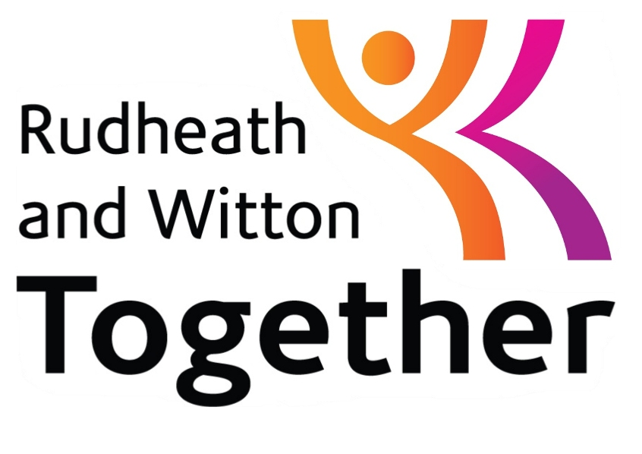
Community Plan
2013 -2015

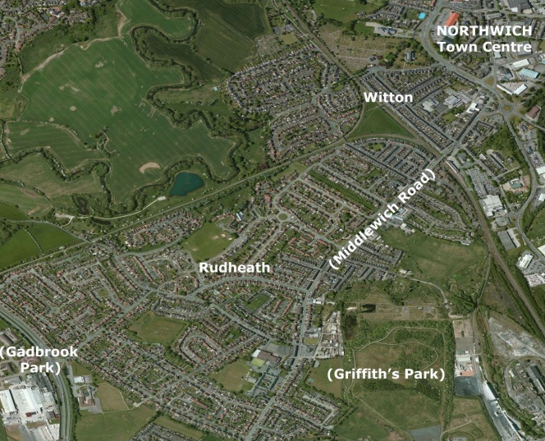

May2013
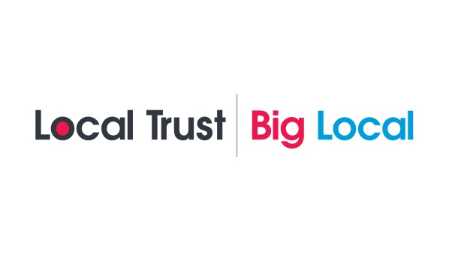
RUDHEATH & WITTON TOGETHER COMMUNITY PLAN 2013 -2015

CONTENTS

SECTION | PAGE NOS
- Overview | 3
- Summary of Plan | 4-5
- The Partnership & Vision | 6-7
- Area Profile | 8-21
- Summary of Findings for Community Engagement | 22-32
- The Projects and Initial 2 Year Action Plan | 33-38
- Acknowledgements | 39

- Overview
This Community Plan has been developed following community and partner engagement. It is based on:
- Desk-top research
- The findings of surveys with local people
- Discussions with local people, organisations and groups operating in the Rudheath & Witton Together area
- Prioritisation exercises
- A call for proposals
- The selection of initial projects and initiatives to support.
This community engagement process has resulted in a profile of the area, a long term vision for it and an action plan of priorities for the coming 2-3 years.
The process has also helped to develop and strengthen the Rudheath and Witton Together partnership that will be responsible for the distribution of £1million Big Local funding for community lead projects.

- The Partnership and The Vision
The Partnership
When the Big Lottery announced that £1million of Big Local funding had been allocated to Rudheath & Witton, discussions were held with a number of organisations to agree how to follow the pathway laid out by Big Local. It was decided that the newly established Rudheath & Witton partnership group set up by Cheshire West & Chester Council should be the interim group to take the initiative forward as they had just started looking at drawing up plans for the area and had been recruiting community reps.
After some discussions with the Big Local facilitator, it was agreed to ask for proposals to run the process of community engagement. A proposal from Groundwork Cheshire was supported in principle, but a request was made by the group to build in support from Cheshire Community Action. The proposal was amended and approved. This resulted in a bid being submitted to the Big Lottery, which released funding to begin engaging local people and developing the partnership further.
The partnership agreed to be an interim partnership as it was mostly representatives from statutory and third sector organisations rather than local people. One of the first tasks which was carried out in parallel to the consultation exercise was to recruit local people on to the group to ensure that the partnership had at least 51% local people represented. This was completed relatively quickly and local people who represented different sections of the area came together to discuss the remit of the group and agree a constitution and role description. The local people involved, as well as being on the partnership also represented geographical areas of the Big Local area to help give each area a voice.
The Rudheath & Witton Together Partnership (RWT) as it is now called includes local people with a range of skills and links. It has changed its makeup slightly over time due to some members with other commitments having to leave and due to others who got involved in the community engagement process wanting to join. The skills that the members of RWT have include youth work, environmental sustainability, regeneration, sport, faith, education, running community organisations and buildings, community work, networking, horticulture, business management, sitting on grant panels to name a few. Members also have good links and associations with local community groups, Churches Together, Cheshire West & Chester Council (CW&C), Rudheath Parish Council, Northwich Town Council, the business community and other organizations and groups. As well as the voting members, the group has associated members or advisors from CW&C, Cheshire Community Action, Groundwork Cheshire, Weaver Vale Housing Trust (WVHT) and their links to other organisations means that they can call on others if necessary, as they did during the engagement process.
RWT are now a group of people who have used the information gathered to develop their vision, identify local needs and begin to identify the best way forward to start using the £1million Big Local money for the benefit of local people based on their needs. RWT will periodically review and identify local needs, monitor progress being made, and will find ways in which the community can take action to meet these needs.

The Shared Vision
To contribute to and complement the wider regeneration of the area and the wellbeing of local people who live in Rudheath & Witton.
This will be done through community based activity which will be well known and well communicated to local people. This community based activity will:
- Develop the skills of local people and local community groups so that they are even more able to help others in the local community and provide services to them
- Provide more people with the skills which will allow them to gain employment and aspire to more ambitious futures
- Improve the local outdoor environment and facilities available in the area so that more people can benefit from them and want to use them for a variety of social, health related and other activities
- Reduce the levels of fuel poverty and debt that local people are in so that they are more able to manage on their income
- Provide support for people of all ages
- Ensure that the community continues to identify and refine its needs and take action to meet these.
Together, the above activity will help to make Rudheath & Witton an even better place to live in.
In 10 years, Rudheath and Witton will have a more engaged community who are aware of the activities and services in the area and who are contributing to more community led activities that provide support and services for the whole community. Local residents of all ages will be more able and enthused to secure work, volunteer and work cooperatively for the benefit of their neighbours, manage their finances, lead healthier lifestyles, look after and respect the open spaces and local environment in the area and contribute to decisions about the area.

- Area Profile
People
Approximately 10,000 people live in the area in just over 4,000 households with an even mix of people of all ages.

Many people have lived in the area for many years, some with multi generations of families still living in the area. In the initial Big Local survey some people indicated that these family and friend links were important to them and so wanted to stay in the area because of this. The turnover of tenants is also relatively low indicating that people like living in the area. A Places survey revealed that over ¾ are either fairly or very satisfied with their local area and their home as a place to live. As in many neighbourhoods, there are a number of local people who volunteer to help the wider community through local groups and Churches, but they often find themselves stretched to do what they want to do and are always looking for more volunteers and support.

Rudheath and Witton was identified as having areas in the 10% most deprived areas nationally. The majority of the population have incomes below the national average with 21.3% of children living in poverty compared to the CW&C rate of 16%, and 21% of households in fuel poverty compared to the CW&C level of 17.7%. Over 80% of households have at least one vehicle.

So, it is an area where people have a variety of different needs, some more deep rooted than others.

Starting Well – Though there are many families in the area who, working with the schools and others are helping their children achieve and have high aspirations, this area has some of the lowest proportions of pupils achieving the required levels and the highest proportion of people with no qualifications in the CW&C area.

From the early years foundation stage 33% compared to the CW&C rate of 57% were achieving a good level of development. At Key Stage 1 achievements in reading, writing, maths and science are slightly higher than the CW&C rates. At Key Stage 2 only 69% are achieving the expected levels in English, and at Key stage 3, 63% are achieving the expected levels in Maths. By at Key Stage 4, GCSE results are significantly lower than the CW&C rates with 45% getting five A*-C GCSEs compared to the national rate of 60%. Those who do move on to A-level or equivalent qualifications do well usually achieving 2 or more qualifications. The Not in Education, Employment or Training (NEET) rate in the area is 5.6% compared to the CW&C rate of 4.1 %.

Working Well - 96% people of working age are employed in the area in September 2012 which is slightly below the CW&C (96.8%) rate. 180 of those of working age unemployed were claiming Job Seekers Allowance for over 6 months. However, a large number of working age residents (18.8%) are claiming at least one key benefit which is higher than the CW&C rate of 13.8%. 25% of those are permanently sick or disabled. However, 60% of tenants receive Housing Benefit, and 30% of the principle tenants in Weaver Vale Housing properties are in employment with half of these in part time employment. So in this part of the community there is a higher reliance on benefits. In addition, jobs vacancies in the area do not necessarily meet the skill set of those who are unemployed and looking for work, and the job vacancies across the CW&C area could only provide jobs for about half of the people unemployed in the Borough. Many jobs in the area are via agencies resulting in unpredictable hours from week to week for many people. This makes it difficult for them to manage their finances.

Low or unpredictable income, fuel poverty, losing a job etc. has left many families struggling to make ends meet which can be evidenced by the high numbers of families using the recently established Food bank in the area and the rent arrears problems that WVHT are dealing with and which are predicted to increase as the benefits changes came in to force in April 2013.

Living Well - 20% of the population have a limiting lifelong illness and the area is in the lowest 20% for life expectancy in the Primary Care Trust area. Life expectancy is 11 years lower than the CW&C average. Five of the six lifestyle indicators, Alcohol Abuse, Adult Obesity, Smoking, Health Eating and Physical Activity indicate health related issues e.g. 29.2% of people are smokers which is higher than the CW&C (19.7%)level; 27.2% are classed as obese which is also higher than the CW&C (22.7%) level with 29% having a body mass index of 30 or more; Fruit and vegetable consumption is lower that the CW&C (28.4%) level, being 20.5%. In a 2008 health survey, 34% of respondents feel they have a long standing illness, disability or infirmity, of which 67% state that this limits their activities in some way. Therefore, health issues remain a concern for many. In the consultation process for this community plan 24% of respondents indicated that they felt that health related projects were important either for themselves, members of their families or others in the community.

32% of respondents in the 2008 Place Survey perceived a high level of anti-social behaviour (ASB) in their local area, 12% higher than in CW&C as a whole. During the consultation for this community plan 27% of people raised ASB as an issue. There were almost 600 ASB incidents in 2011 and the levels are 3 times higher than the Northwich and Rural Area average. Of the seven anti-social behaviours identified, the three perceived biggest problems were:
1. People using or dealing drugs (61%)
2. Teenagers hanging around on the streets (60%)
3. Vandalism, graffiti and other deliberate damage (50%).

This has affected some people’s quality of life, and though people involved in the Big Local consultation did not solely link ASB to young people, they did feel that to reduce this more activities are needed for young people to engage them in more positive activities.

Geography
The neighbourhood of Rudheath and Witton consists of two areas on the eastern side of the town of Northwich, Cheshire and covers approximately 640 hectares. It is based in the Borough of Cheshire West and Chester and is within 1 mile of Northwich Town Centre. Two main roads run through the neighbourhood; Middlewich Road (B5082) running from NW-to-SE is the main road connecting residents to the town of Northwich and the A556 running from E-to-W is the main through roads to Chester and Knutsford. Northwich station is located on the NE boundary and links the area to both Chester and Manchester.
The Manchester to Chester railway line runs across the neighbourhood, cutting Witton into two parts. The town’s railway station is in this area and the two parts are linked by one road across the railway bridge. This forms a real physical barrier between the two halves of the area and so Rudheath and Witton are seen by many as distinct areas, with some people identifying more with their local area rather than seeing themselves as living in of Rudheath and Witton.

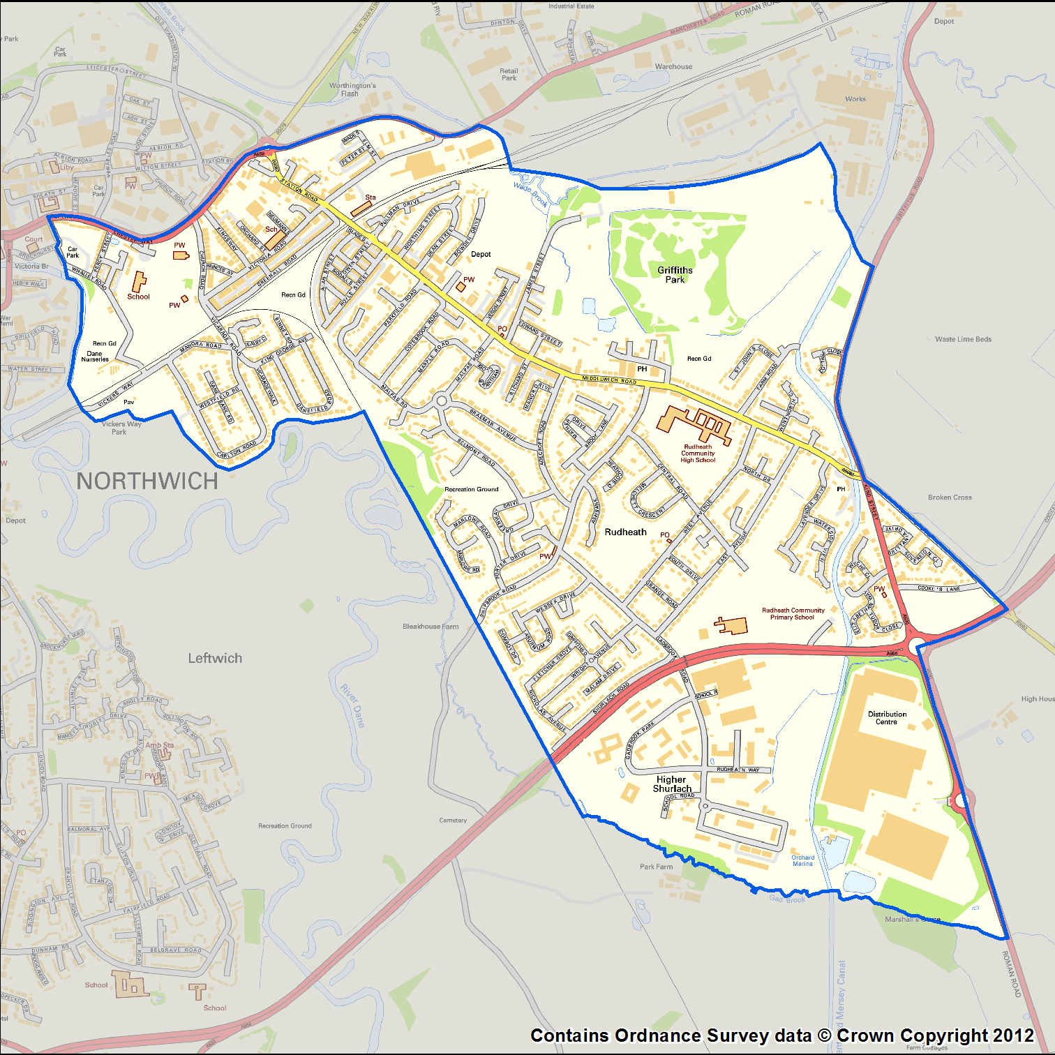

How the Area Has Developed and Changed
The area has ancient roots, based on the salt deposits of the region (the Romans called the town Condate), but grew significantly during the nineteenth and twentieth centuries. This was largely due to the Brunner Mond chemical industries surrounding the processing of salt into soda ash and chlorine related products, with three large works at Winnington, Wallerscote and Lostock, and an associated canal which run through the area.
During the first half of the twentieth century, Brunner Mond took part in a merger to create ICI which therefore became the principle employer. Other smaller industries grew up around these works, and the area prospered.

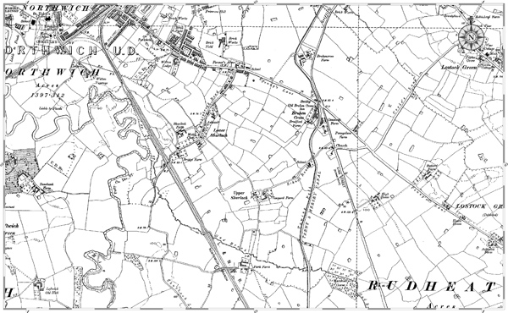

More recently, Gadbrook Park developed and is a fairly large business park on the south side of the neighbourhood, the other side of a principal duel carriageway, the A556. Employers include bakers Frank Roberts & Sons who have been in Rudheath since 1887, Morrisons who have a large distribution centre, The Hut, Barclays, Weaver Vale Housing Trust whose HQ is here and many other smaller businesses. This business park is now a Business Improvement District. There has been links between some of the businesses and the community over the years and some involvement with the consultation with some of their employees. More recently more formal links with the High School have also developed.
The legacy of this industrialisation has left some large areas in need of development, but despite much of this land being purchased by a developer, no progress has been made to transform this land which remains derelict.

There are a number of open spaces in the area. Part of the Dane Valley runs through the area and some of this is managed by Northwich Anglers and is used by many residents in the area for dog walking as well as angling. The valley is a flood plain, which still floods on occasions, preventing further development. There are also other recreation areas which have developed and have had recreation equipment added and updated over the years.

There are also a number of small businesses along Middlewich Road and a few other small businesses on other streets, such as take-aways, hairdressers and barbers, newsagents etc. Many of these have helped with the consultation process for the community plan.

Housing
Both Rudheath and Witton were developed by building large estates of social housing in the second part of the 20th Century, as well as smaller numbers of owner-occupier housing on the peripheries of these more industrial areas which have been built towards the end of the 20th Century. This housing added to some of the more traditional Victorian and Georgian housing closer to Northwich Town Centre.

Some of the social housing, transferred to Weaver Vale Housing Trust in 2002, is now occupied by owner-occupiers who bought their houses under the right to buy scheme. A large allocation of housing in the neighbourhood (22%) is owned by Registered Social Landlords, primarily Weaver Vale Housing Trust. WVHT conducted a mandatory Status Survey in spring 2010 and the findings in this area were that the quality and condition of their home and the neighbourhood as a place to live all scored high marks in overall satisfaction.

There has also been a planning application approved for other housing, though there has been no progress on this development for some time and it is uncertain when or if this development might take place. If it does there will be more demand for the open spaces and services in the area.

Administrative Boundaries
The whole area comes under Cheshire West & Chester Local Authority, which is a new Unitary Authority formed in 2010 following the merging of County and District Councils. With the recent Boundary Commission changes Rudheath and Witton has become one ward, whereas it was previously a split ward.
The Witton area is part of the Town Parish of Northwich, while Rudheath has a distinct identity as a civil parish, with its own Parish Council.

Facilities
Rudheath and Witton has a range of local facilities as well as the businesses outlined above. The accessibility of these services and facilities is excellent as they are situated throughout the community within walking distance for most people. Many are also on or near the main bus route through Rudheath and within 2 miles of Northwich train station / town centre.

An audit of these facilities was carried out in 2012 and the key facilities are as follows:

Adult Learning Centre
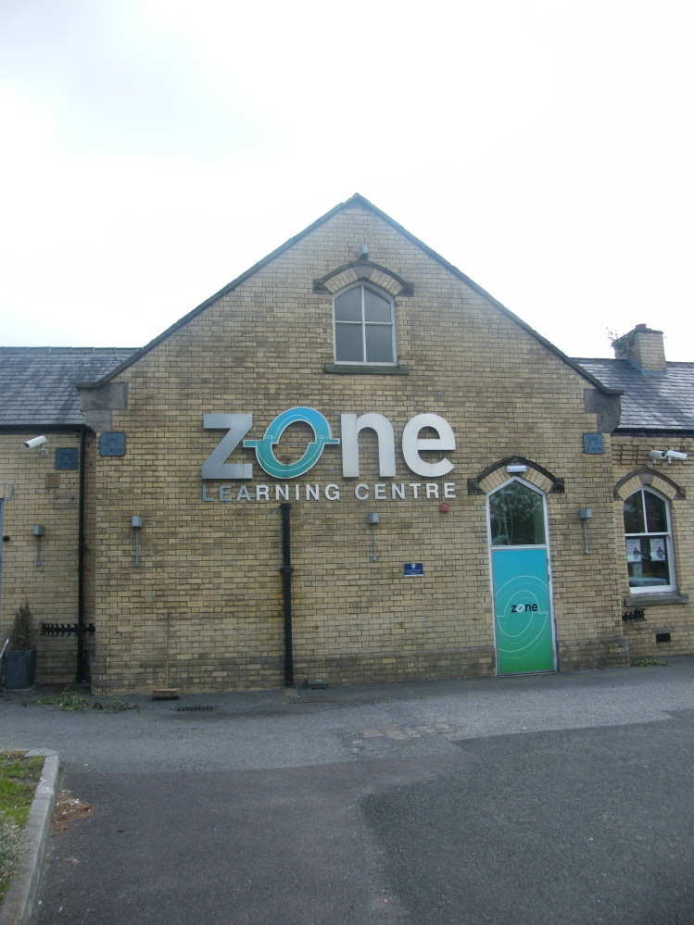
The Zone

Bank None. (The NatWest in the area was recently closed.)

Business Park Gadbrook Business Park

Children’s Centre Victoria Road Children’s Centre

Community Centres Bethel Church (Where many community activities are based from)

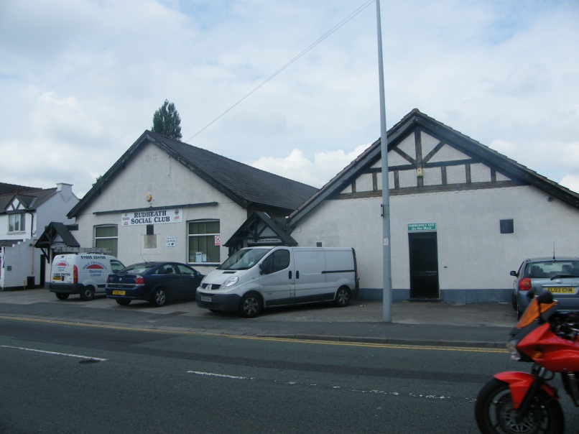
Rudheath Social Club (Which hosts many activities and groups)

The Venue (Though currently underutilised)

The Gladstone Club

High School
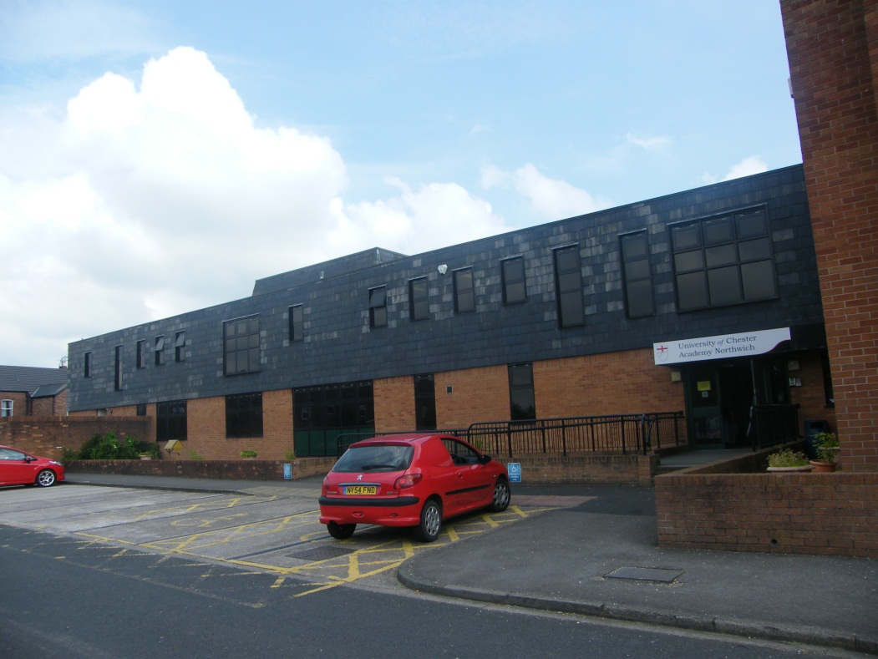
University of Chester Academy Northwich (UCAN)

Leisure / Sports Rudheath Leisure Centre

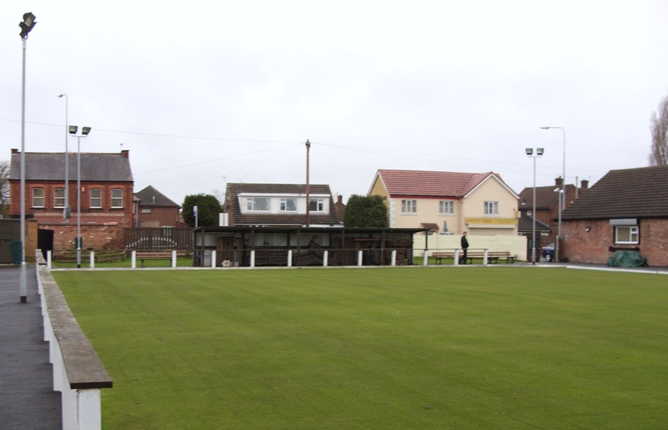
Rudheath Social Club & Bowling Green

Dave’s Gym

Open Spaces

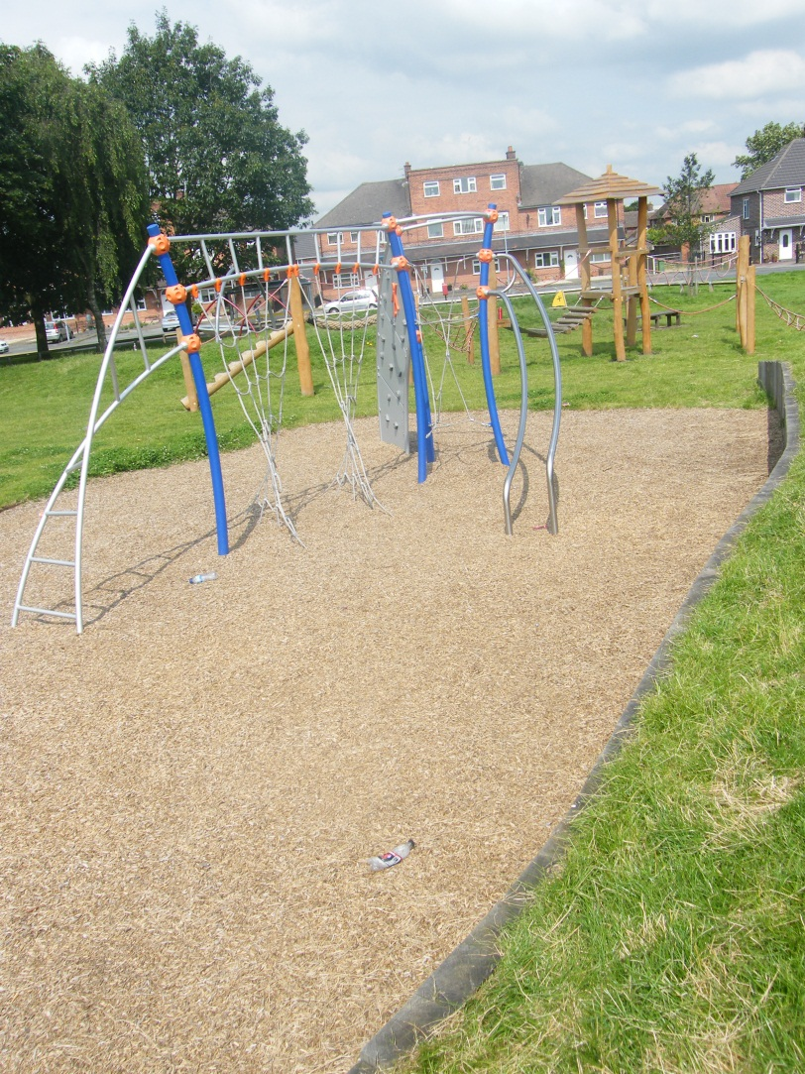
Belmont Road Open Space

Gadbrook Park Recreation Area

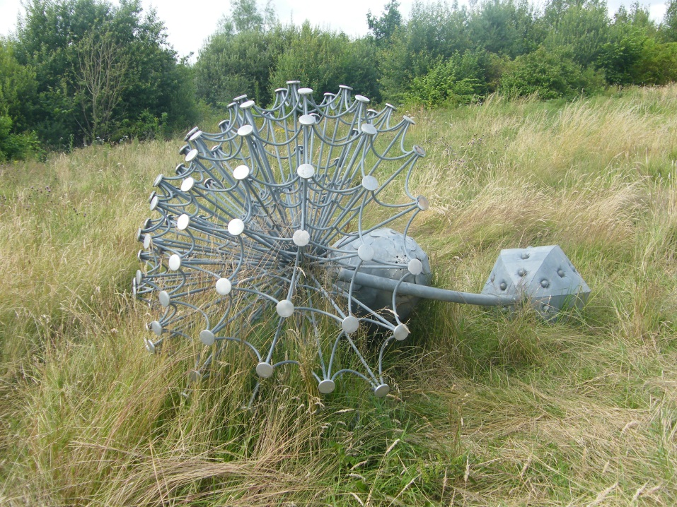
Griffiths Park & the associated St John Playing Fields

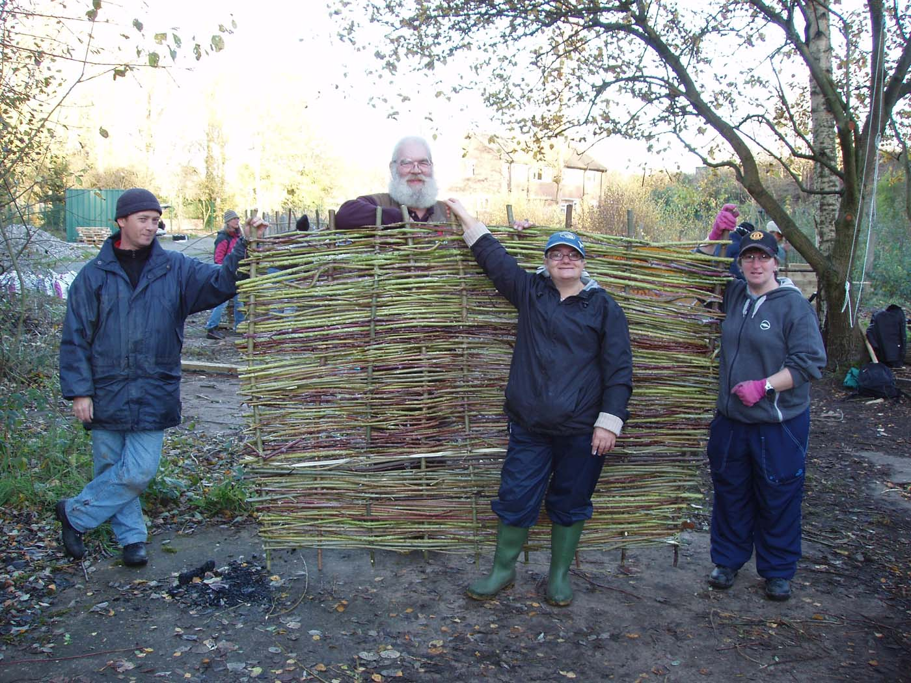
Grozone Community Garden and Food Growing Area

James Street Play Area

Roker Park
Places of Worship

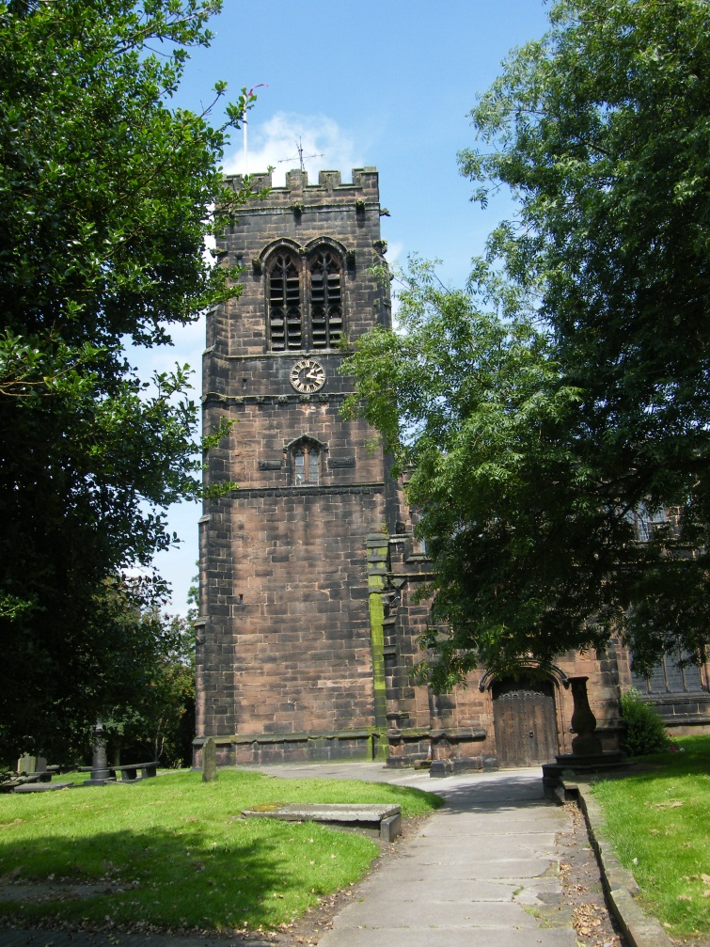
Parish of St Helen’s - Church of England

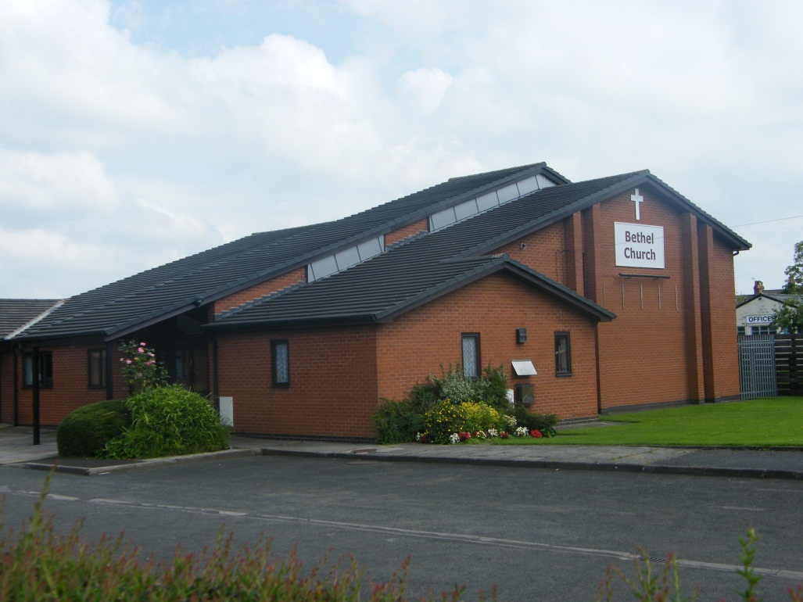
Bethel Church

Methodist Church

Post Offices Middlewich Road Post Office

Rudheath Sub Post Office

Primary Schools Witton Church Walk

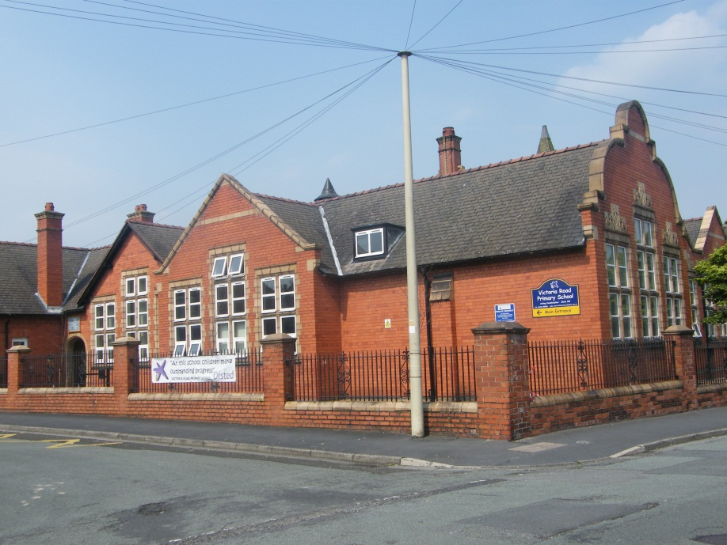
Victoria Road Primary

Rudheath Primary Academy

Surgeries Middlewich Road Surgery

Rudheath Dental Health Centre

Current Activities & Provision

There are a number of organised activities taking place in the area organised by third sector, faith, statutory and private organisations. An audit in 2013 outlines many of those activities which run in the area:

Activity | When | Age Range | Where | Cost | Contact Details
Anglers | Varies | Any | Rudheath Sports and Social Club | Varies, some at no cost if a member of the Club | 01606 42935
Bingo | Monthly | Various
Bowling | Outdoor Apr-Oct  Indoor  Nov-Mar  Different timings | Various
Dance classes | Tues 6-10 Wed 3-10 | Different times for different groups
Darts | Mon 7-10  Thur 7-10:30  Sun 7-10:30 fortnightly | Various
Dominoes | Tues 7-10 fortnightly  Wed – 7-10:30 fortnightly | Various
Keep Fit | Mon 7-8 & 8-9  Thurs 7-9 | Mixed
Pigeon Club | Apr –Sept | Mixed
Pool | Wed 7-10:30 | Mixed
Activity | When | Age Range | Where | Cost | Contact Details
Fishing NAA | Any daylight | Any | Dane Valley | Juniors £10 | Kevin Rimmer  07947 977585
Sports and leisure activities during school holidays. | Flexible | 12-17  Male only | The Children's Society | Free but for young people referred to the football project | Paul O’Neil  01606 333589  Paul.O’Neill@childrenssociety.org.uk
JuJitsu | 6-7pmWed | 5-7 | Rudheath Leisure Centre | Fees | David Flaherty  Cheshire Budo Federation  Rudheath Leisure Centre  01606 41051
 | 7-8pm Wed | 8-10
 | 6-9pm Wed | 10-15+
 | 9:30-10am Sun | 5-15+
Ballet | Fri/Sat | 3? Upwards | Dave’s Gym | Fees | Wanda Kinder-Berry  Royal Academy of Dance
Boxing | Saturday AM |  |  |  | 01606 330 682
Stage Coach(drama) | 10am -5pm Sat/hols | 5-16 | Victoria Road Primary School | Fees | Sue Chat  Stage Coach  01606 45132
Rudheath5-12 youth club | 6-7:30pm Fri | 5-13 | The Venue | £5 per year plus 50p weekly, or £1weekly | Hazel & Robert Stephens  07981248598  Rudheath512@aol.com www.rudheath5-12.webs.com
Amplify Music Club | Evening  Mon | 11 -19 | The Venue | Free | CWaC Youth Service
Energize | 2:30-5:30 PM Sat monthly | 5+ | Bethel church | £2.50 | Linda  07719656619
Activity | When | Age Range | Where | Cost | Contact Details
Rudheath football club | Varies Teams play on Sat & Sun with training on weekdays | 5+ | St Johns Fields playing field |  | Mike Alcock  07578 336691
Hot stepping 1 | 6-7pmWed | 7-12yrs | Rudheath Leisure Centre | £2.50 | Rudheath Leisure Centre  01606 41051
Hot stepping 2 | 7-8pm Wed | 13yrs – 19yrs |  | £2.50
Cheerleading | Sat, Sun, Mon | 5yr+ 16yrs + |  | £2.50
Baseball | 3-5pm Sat | 8yrs + |  | Varies
Basketball | 1-3pm Sat | 16yrs + |  | Varies
Badminton  Rudheath shuttles | 10-12noon Sat | 8yrs+ |  | £5 | Paul Pritchard  01606 42515
Table tennis, tennis, badminton,  Football, basketball | Daily | 5+ |  | Varies | Rudheath leisure Centre  01606 41051
Rudheath guides | 7:30-9pm Wed | 10+  Females only | Lostock youth club | £15 per Term | Rachel Aldus  01606 76972
Witton Church Walk Tea & Tots | Monday 9:30-11 term time only | Toddlers and parents | Witton Church Walk Primary Community Room | £1 for one adult and up to 2 children | Witton Church Walk School  01606 43128
Activity | When | Age Range | Where | Cost | Contact Details
Rudheath  Rainbows and Brownies | 5-6pm & 6-7:25pm Wed | 5-11  Females only | Victoria Rd Primary School | £15 per Term | Mo 01606 810452 or  via Victoria Rd primary  c/o Rachael Aldus 01606 76972
Grozone | 10am-3pm Wed & Sat | 16+ | Grozone, Dane Nurseries | Free | Cynthia Moore  01606 723173
Dane Valley Orchard | Any time | Any |  | Free
Foodbank | 1:30-3PM Tues & Fri | Any | Bethel Church | Free, only through referral
Careers Advice | Tue & Fri  9-5 | Any | The Zone | Free | 01606 288540
Foundation Learning Courses | Mon, Tues & Thur 9-3 | Any
IT Courses | Tues 9:30-4:30  Wed 1-5 | Any
Young Carers | Thur 5-9 | Young carers
Work Club | Friday 9-1 | Job seekers
Self-employment support | Friday 10-3 | Any

In addition there are services that are provided on wider basis across Cheshire West and Chester or in the Northwich and Winsford area. These are provided by 3rd Sector Infrastructure Organisations or other 3rd Sector organisations. However, these commissioned services are limited in what they can offer and they tend to be commissioned year on year so are not guaranteed beyond March 2014 e.g. volunteer bureau, support to voluntary organisations, debt and benefits advice.
- Summary of Findings from Community Engagement

This section follows the different stages of community engagement that lead to the actions outlined in the forward action plan.

STAGE 1 - Initial Consultation & Identifying Issues and Themes
In 2011, as part of the first stage Big Local process, sessions were run using a participatory appraisal approach. These sessions were held at the Rudheath Funday, Bethel Church, Shurlach Wives meeting, Rudheath High School with School Council who had already got information from their peers, learners at The Zone, Grozone, Rudheath Primary School, Academy day at Rudheath High with parents, Rudheath Social Club, Rudheath Primary School, Community Reps meeting. There were also discussion groups held, community events, interviews with local people. Outreach work with young people was also carried out to get their views. Surveys were dropped off at all local shops, hairdressers/ barbers, cafes, GP surgery etc. in the area and picked up or carried out via the community reps. Overall 422 people fed in to this process.

There was a high proportion of people indicating a number of positive things about the area from open spaces (30%), being near to the town centre (21%), Schools (12%), Good neighbours and community spirit (12%) to name a few. The discussions held also revealed that though people felt that there were issues in the area, that Rudheath and Witton had many positives and that many people liked living here and had a long history of living in the area.

The findings from Stage 1 revealed some priority themes as outlined below:

Environment
30% of people valued the open space in the area with some people picking out specific areas that they used regularly. In general, people liked the fact that there are a number of open spaces - both formal parks and the Grozone project and the Dane angler’s area etc. However, there were also many concerns about the condition or quality of the provision in some of these parks and open spaces, that some of them were underutilised, that they were not really animated or inspiring and that they needed improvements. 95 people had ideas relating on how to improve the situation and 24 people have said they would be willing to volunteer in this type of activity. Links were also made to the health agenda and how these spaces could be used to improve people’s physical and mental health.

Community Facilities
Community buildings and venues also featured. Many people identified that there were a variety of activities taking place in building such as Rudheath Social Club and Bethel Church. There were some concerns that some venues were not providing the style of modern venue that people now expect, though they understood that the costs of upgrading venues could be an issue for volunteer run centres. Whilst some think a new centre is needed, others feel that refurbishment, better use and coordination of the venues that are already available may be a better way forward, to reduce the financial burden and pressures on volunteers and to avoid competition between community run venues. 7 people who were not already engaged, were interested in assisting with the running of community centres. There was recognition that training and support may be needed for those willing to volunteer in running and managing buildings.
Debt and Personal Finance
5% of respondents admitted that they were finding it hard to pay their bills, getting in to debt, worrying about losing some benefits due to the changes that are coming, and others said that they had friends who were having financial difficulties. Suggestions included establishing more accessible advice on managing debt and/or practical ways of saving money, as many people said that they didn’t know how to get help. People felt that this support should be targeted at people most in need and that service providers engaging with these families should be signposting them on to the appropriate agencies or projects where necessary. There were also concerns and uncertainty about the changes to the benefits system in 2013.

Jobs, Skills & Training
There is a lot of concern about job and employment opportunities, skills mismatch and low aspirations, with over 14% of respondents flagging this up as an issue. Programmes run at The Zone and by other organisations were valued. There was a recognition that better links between local businesses and training and education providers was needed as well as a more supportive programme for people who were struggling to find work, training or volunteer opportunities. There were also a number of people concerned about their current job security, others who had very unpredictable working hours as a result of getting work through agencies, and many people felt that jobs in the area were not always advertised via Job Centre Plus and so it was hard to find out what opportunities there were.

Young People
There were concerns about young people and that there are not enough facilities for them in the area. This was a common comment from all age groups, with 35% people indicating this as an issue. 27% linked this issue to Anti-Social Behaviour and 14% of people flagged up youth gangs as an issue. Some reference to parental control and needing to support families was also discussed. However, nearly two-thirds of people did not flag up ASB as an issue and were keen that young people in the area were not all seen as causing problems. There was also some discussion that just targeting the young people may not be enough and a family approach may be more effective. 34 people have indicated that they would be willing to volunteer or do volunteer with this type of activity. There was some feedback that training would be needed if people were to volunteer in this area to endure that safeguarding children was prioritised. Discussions revealed that this was a complex issue and that a more proactive approach in dealing with issues and linking improved facilities and activities to appropriate behaviour would be beneficial. Though there appears to be quite a lot on offer for young people, discussions with young people revealed that not all of this provision was affordable or that it only met the needs of a few young people.

Other Issues
Less commonly mentioned issues included:
- Older people being socially isolated. Events, activities, clubs and befriending projects have been suggested as ways of minimising this isolation, though there was a feeling that service providers should be raising this issue more with each other or at least signposting to and making people aware of what support there already is.
- Health concerns. Some felt that this was a health and social care responsibility, but others felt that local projects could help to tackle physical and mental health issues as long as they were linked in with the other services.

Volunteering
There were over 60 people who have indicated that they would be willing to get more involved in volunteering in the area. Supporting, handholding, guiding, providing shadowing experience and encouragement were all seen as important to volunteers, as well as coordination and finding the right volunteer opportunities for people.

Communication
Communication about what is happening in the area was also mentioned as many people felt that they were missing out on things or did not know about projects or activities that were discussed with them during the consultation.

STAGE 2 – Identifying Ideas

Based on the above findings, RWT agreed that the next stage should focus on the 5 key themes that had been flagged up as the most important themes by the initial consultation and desk top study.

Between May and October 2012, themed sessions were run to investigate these issues further, and links were made to other events or groups where discussions also took place. During this stage 247 local people were involved in more in depth discussions and networking. The 5 themes discussed, which were based on the issues raised in Stage 1, were:

- Environmental Improvements

- Community Facilities Improvements

- Debt and Personal Finances

- Jobs, Skills and Training

- Activities and Support for Young People

In addition, communications were felt to be something that needed to be progressed to ensure that people were aware of what the group was supporting, what was on offer in the area and what was having good results. As a result RWT set up a website and included in this is a Google Map of facilities and venues in the area with links to groups’ websites where appropriate. There has also been training for some local people in Community Journalism which will to help get more information about what is going on in the area out into the community. Whilst there is more to do on this, a good start has been made.

The following section outlines the findings and ideas that came forward at this stage of engagement and these summaries indicate the activities that RWT would like to support over the next 5 years:

Environmental Improvements

- Some open spaces need improvements and more support to keep them litter free and animated. Some specific issues flagged up include Gadbrook Park Recreation Area which needs drainage improvements, additional equipment and more for older children/teenagers; Grozone which needs better access and more growing areas; St John’s Field which needs better drainage; Griffiths Park which needs better maintenance. People also noted that some other open spaces had had recent improvements such as Belmont Park (though there had been some initial teething problems with ASB which had been resolved). There were also some suggestions about more volunteers being needed to help with the maintenance and activities in some open spaces such as the community orchard, and local organisations using local venues for their outdoor activities.
- With energy bills getting more and more expensive, people saw the need for reduction in energy usage. The focus of the discussion was more linked to helping those who are struggling to pay their bills and who are in fuel poverty to have more energy efficient homes and a better understanding on being more energy efficient, through this was something that everyone could do. There was also some discussion on local energy production either on a community level of household level using solar heating, ground source heat pumps etc.
- Due to the levels of traffic in the area there was discussion about initiatives such as walking buses for school children and the promotion of cycling and cycle training for children to reduce the need for car use. Changing the emphasis of the roads in the areas away from cars was also discussed.

Community Facilities Improvements

- There was an acceptance that Community Centres take a lot of input to run and that the centres such as Rudheath Social Club and Bethel Church are providing some very good provision in the area where many people benefit. Refurbishment, upgrading and additional facilities within some of the current community buildings was seen to be important in making some venues more open to the wider community and therefore more viable in the long term.
- Some of the more successful community buildings have very committed volunteers and people felt that they needed help in recruiting more volunteers, and providing more training and support for them. Some centres are run more like social enterprises even if they do not classify themselves as social enterprises.
- The discussions indicated that the future plans for The Venue were unclear, though CW&C were interested in finding an organisation who would be interested in managing this centre. The usage is currently minimal and there were some concerns that the centre isn’t viable and that a full feasibility /viability study should be undertaken. There are a few activities that are based in neighbouring communities for the benefit of local people, and they may be able to locate locally either at The Venue or one of the other community buildings. It was felt that any study should include consideration for the other venues and how different management and promotion of The Venue could take clients away from other local community venues so leaving them less viable.
- Publicity for the community centres and what takes place in them was also seen as inadequate as many people were not aware of what was on offer.
- There was also some discussion about the use of non-building venues. There were many outdoor spaces that could be used for activities, but it was not clear how groups could get permission to run their activities in these spaces and share the spaces.

Debt & Personal Finances

- Some of the discussion around this agenda was that there were various services providing help to people e.g. CAB help and advice lines and volunteer training, Christians Against Poverty, WVHT debt advisors, Barclays managing debt service etc. - this could be confusing for people who need help.
- Concerns were expressed about the changes in benefit system that were coming and how this could cause more financial and debt issues for people who cannot get a job.
- There was mention of a wider Credit Union but no one was clear about how you could join this.
- Fuel poverty is an issue and seems to be increasing. Green Doctor and fuel poverty advice – including training volunteers / community champions has worked in other areas.
- A Foodbank was being developed for the area during discussions which was seen as essential for people with major issues or in financial crisis.
- Food growing projects could reduce people’s expenses, as well as helping to improve health.
- Toy library and/or Tool library or similar initiatives might be welcome.

Jobs, Skills & Training

- Literacy and numeracy skills are still an issue for some people, with some parts of the community using English as a Second Language.
- Learning Champions are a positive thing, but not everyone clear on how it works.
- The training on offer needs to meet local employer needs where possible to maximise people’s chances of getting a job, but there is also some basic skills that some people will need prior to this.
- Programmes to address confidence and self-esteem and getting back into looking for work / back to work support to people with mental health issues e.g. Successful Transitions, Making Space, Short Programmes at The Zone
- Matching local people to local jobs is important, and the new Kaonics package that was developing during the discussions and that is now up and running may help to fill this gap.
- Links between Gadbrook Park and UCAN high school are developing.
- Sports coaching and training can provide a valuable discipline for many young people in the area as well as providing employment.
- There was a feeling that though there was provision available to support people, there were gaps in this provision. Many of the community run projects in the area could contribute to developing skills and transferable skills and the scope for this shouldn’t be underestimated.

Activities and Support for Young People

- The provision of activities for young people are limited in the area and do not cater for all young people.
- Some provision is not in the area and so less accessible for many young people due to public transport limitations.
- Sport provision in the area is improving particularly with the location of Rudheath Juniors becoming more central.
- There is a limited amount of affordable and safe places for young people to meet and ‘chill’ and not be seen to be hanging around on the streets.
- There is interest in environmental issues and improvements to the local environment, but there a few opportunities for engagement in this.
- Older young people are more and more concerned about job opportunities for them in the future.
Communications

- To ensure that as many local people as possible in the area are informed about RWT, its vision and aims and the activities it is supporting.
- This should be done using a variety of media and methods including the RWT website and other partner websites, Facebook, Twitter, the local press and internet radio, meetings, attendance at events and face-to-face contact.
- Partner agencies should also be informed of progress and invited to RWT meetings where it is felt that this would progress the aims of RWT and lead to better outcomes.
- The projects that we support should all ensure that they also promote what they do and how it links to RWT so that the wider community are aware of what is on offer and so that potential beneficiaries or volunteers are given the opportunity to get benefit and/or get involved.
- The need for someone or an organisation to coordinate this.

STAGE 3 – Prioritising & Action Planning

From the sessions run in Stage 2, we spoke to a number of the groups and organisations who might be potential delivery partners. This was done on an individual basis and also together in small groups. A number of project ideas that had been briefly outlined in Stage 2 were logged that if developed further could help to tackle the issues identified.

A sub-group of RWT was formed to develop a prioritisation matrix, so that each idea could be assessed against a number of criteria.

Initially projects were ranked according to the level of support local people had given to each project idea. This helped to list the projects in order of popularity.

Each project was then assessed in relation to the themes developed as a result of the Stage 1 engagement, and for each theme that it met, the project received one point. Though priority themes has been identified by the community, the group felt that individual projects shouldn’t be pigeonholed under one theme, as in many cases they would contribute to a number of agendas, and where they did were likely to be stronger projects. These themes were:

- Communication
- Young People
- Environment
- Debt & Personal Finance
- Jobs & Skills
- Buildings & Facilities
- Health – Physical, Mental & Emotional

For this set of criteria, a project could score a maximum of 7 points if it met all of the themes.

The next set of criteria was associated with the Big Local aims and the principles that RWT felt were important. These were seen as the most important aspects to assess projects against as it was by achieving these goals that projects would really make an impact. Therefore, some of these were weighted as they were more crucial to the potential success and sustainability of a project. These were:

- The project is financially sustainable
- The project increases local capacity
- The project increases local people’s skills
- The project makes Rudheath & Witton a better place to live
- The project makes a real impact or difference
- The project could attract other funding
- The project fills a gap in provision
- There are known local people willing to support or run this activity

In principle a project could score a maximum of 16 points for these criteria.

The projects were also checked against ineligibility:

- The project is a wholly statutory responsibility or is being done elsewhere adequately
- The project is unlikely to become self-sustaining
The scoring for these was -25 each, so that when all the scores were added together across all criteria, a negative score would indicate the projects ineligibility. This would not mean that the project idea was not valuable, but that RWT could not support it as part of the Big Local initiative. There were some difficulties in assessing whether or not a project was a statutory responsibility and where this was unclear a judgement had to be taken.

This process gave a shortlist of projects that the group felt that it should pursue further. A proposal form was developed and organisations and groups were approached to submit their proposals which would be assessed by RWT. They were given support where necessary to complete their proposals and 9 proposals were put forward.

Not all of the prioritised ideas had proposals submitted. Some of this was because the groups and people we spoke to felt that they were not yet ready to develop their ideas, due to them not having enough capacity to take on more, or because they were already progressing projects with funding and did not currently need assistance.

At the first assessment meeting no decisions were made on whether or not to support a proposal, but some were rejected as it was felt that they were either too expensive, that they scale was inappropriate, or that the service was already being provided. A number of questions were raised and so following this meeting, the applicants were contacted after to clarify the specific points about their proposal. Where there were obvious gaps, local organisations were approached again to see if they wanted to submit a proposal, but only one more proposal came through. The groups with the remaining and refined proposals and the group submitting a new proposal were invited to another meeting to present their case and answer questions and discuss their proposal with RWT. As a result of this meeting, a number of proposals were supported which form part of the first 2 year action plan. These are outlined in the next section.

Discussions were also held about the Locally Trusted Body and the process is underway to choose which organisation will be appointed to take on this role.

Successes & Actions Taken Already

Though the first two year action plan does not include everything that was prioritised by the group, this section outlines some of the community, faith, third sector, public sector and private sector activities that have developed over the last year or so, which we feel should be noted. These projects have developed partially as a result of the Big Local engagement process, the development of the Rudheath & Witton Together partnership, other discussions held on a wider basis in the Northwich and Rural Area, and also through the efforts of volunteers, the third sector, schools and the local Parish, Town and Unitary authorities working in their own right. Therefore, some of the issues raised in this engagement process have been tackled or are starting to be tackled. Actions that have resulted include:

- The establishment of the Rudheath & Witton Together website – www.rudheathandwitton.org.uk

- The physical infrastructure of the Grozone site being improved significantly

- The set up of a Foodbank based from Bethel Church in the area

- The establishment of the Rudheath & Witton Adventure Group with a pilot project working with young people engaging in ASB being trialled successfully

- The establishment of the Dane Valley Orchard

- A very successful Big Lunch programme in 2012 with plans developing for 2013

- Successful and well attended Rudheath & Witton Funday

- Some initial improvements to the drainage on St Johns Field

- The development of changing room facilities at Rudheath Social Club for sports activities

- Parenting skills programme running from the Children’s Centre

- Academic results at University of Chester Academy being the best ever in 2012

- More adult learning programmes running from The Zone

- Better integration of benefits and financial advice services

- Funding secured for outdoor gym at Roker Park

- Better links between the schools and private sector in the area

- The Kaonics job search portal supported by a number of agencies in the area

- More coordinated back to work programmes and job seeking support.

RWT are not claiming credit for all of these actions, but feel that for some of them, they have provided some support and/or encouragement.

The list above helps to give our community plan a wider context, so that it is clear how the projects that RWT will be supporting will complement this other activity.

- The Projects and Initial 2 Year Action Plan

This section outlines the priorities which RWT wish to support in the coming 2 years. These projects will help to address some of the needs and priorities in the area, will begin to build more capacity and will involve more local people in taking action to make the area an even better place to live in. They all meet the Big Local criteria and also hit more than one of the RWT identified priorities. The projects selected are:

Pennies & Pounds

This project will promote awareness of social welfare changes as a way of enabling people to deal with their finances as efficiently as possible, and then equip them with the skills to manage this online. Run by West Cheshire Citizens Advice, any member of the public in the RWT area who has an issue with benefit claims, debt, or household budgeting issues could be a beneficiary.

Many people receive advice on financial management, but lack the skills to utilize the advice given. This project will recruit and train volunteers from the area to deliver extended training, support and guidance to residents to enable them to retake control of their lives and manage their money.

A typical participant journey would involve someone:
- Having debt or benefit problems, or struggling to make ends meet (Identified through promotional work as part of this project and referred for advice).
- Receiving benefits and debt advice from existing sources of advice.
- Being identified as struggling to work out how to prioritize spending each month.
- Receiving assistance from this project to use “Cashflow”, an online tool which to identify debts, and make offers of payment. The CAB would authorizes their financial statement, which would then be accepted by creditors.
- Receiving assistance from this project to make on-line applications for Universal Credit and other benefits (as part of the “digital by default” agenda). The client would be shown how to use the internet to keep the DWP up-to-date with any changes in their circumstances, to reduce error and benefit overpayment.
- Receiving assistance from the project to use existing on-line tools to plan their household budget, and begin to make decisions about future spending.

A project development worker will promote, recruit, train and mentor local volunteers to help provide the service and additional training will be provided. An IT room will be equipped at the Northwich Anglers premises in the RWT area where the training and support will be delivered from.

- Outputs - 900 people per year will be helped with financial issues. 30 local people will be trained to assist others.
- Outcomes – More people in the community will develop skills which will allow them to support and signpost others who are in financial difficulty, helping them maximise their income and minimise their outgoings.
- Impact - The project will make people more financially resilient and equip them to manage their money more effectively by building in various skills that will help them reduce their levels of debt, maximise their benefit income, reduced errors in claims. This will reduce the levels of poverty in the area as well as the stress that people have as a result of having financial difficulties.

Rudheath Social Development Plan – Solar Panels

The Rudheath Social Club is one of the main hubs in the community where many groups and clubs meet. The Club have developed a pan for the future to make it more sustainable so that they can continue to serve the community in the heart of the community. Over the last few years they have been improving the efficiency of the building and changing their practices to consume less energy. Whilst this has made a big impact on their bills, the running costs are still high and after undertaking an assessment on how to lower their bills further, the best option was for solar panels. Once installed these will reduce their bills significantly, but the group does not have the capital at the moment for the purchase and installation. They therefore need a loan which they can pay back over time due to the savings made.
There is nowhere else locally in the community that has these facilities which will include a sports field, adjacent changing facilities, catering and facilities which have been built for the purpose of the people to use which is not a profit making enterprise.

- Output – Solar panels fitted to Rudheath Social Club providing an average of ?? Kwh/month which will help to reduce their energy bills by??%.
- Outcomes- The social club will be able to focus more of its time on providing services and activities for local people rather than fundraising and it will become more sustainable.
- Impact – More community based activity in the heart of the community and a centre that is more financially sustainable,

Rudheath Social Development Plan – Roof & Pitch

Rudheath Social Club has worked hard over the last few years to improve the facilities in their building and land near it. This is so that a wider proportion of the community can use the building.

They have begun to improve the building following significant fundraising success with the addition of changing rooms and showers, but there are other parts of the building which are suffering from roof leaks which is restricting more family oriented activities from taking place. The roof in the small function room is in need of repair work so that this room can be used for activities and as a family room at weekends. Repairs to this roof will therefore allow more of the building to be used for community uses and ensure that different users can use the building simultaneously and independent of each other. This is particularly important for activities with children where there may be safeguarding issues.

In addition to these works the Club have also been improving St Johns Field adjacent to the Club so that local football teams can be based in the area. Initial works to improve the drainage revealed that there were more significant drainage issues than initially thought and so local teams have to travel out of the area to train and play matches. After investigations by United Utilities and others a drainage solution has been developed. This would mean that the pitches could be used by teams and for informal use all year round. The drainage works would be carried out by groundwork and drainage specialists.

- Output - 100m2 of floorspace in the building will come back in to community use for a variety of family based activities. At present 190 people are registered with the football clubs and they attend coaching and games every week but after talking to schools and other groups, including aspiring female players, they anticipate that when the facilities are fit for use there will be over 500 people per week using the pitches. This will make the Rudheath junior football club more sustainable
- Outcomes – The additional usage of parts of the building will help to bring in more income to the Club so that they can undertake other improvements and get more people involved in running activities. The pitch improvements will lead to more inclusive sports and a more comprehensive sports offer in the area.
- Impact - Together, these two improvements will benefit a much wider section of the community and help to get more people involved in community activity.

RWT Communication Project

The Cheshire Media Academy is a local not-for-profit project working with young people to offer an insight into the world of media. In response to RWT needing help with its website and communications Cheshire Media Academy put forward a proposal which would do this whilst training and improving the prospects and skills of a number of young people, as well as providing promotional material for a number of local groups and projects in the RWT area.

The aim of the project is to work with the community in Rudheath & Witton by providing a hub of communication via a network of resources, which will create an awareness of RWT and the projects running in the area.

This will be done by engaging with local young people through the established students of Cheshire Media Academy who will transfer their learnt skills to the RWT students.

These young people, with staff support, will then work with the wider community, creating an inter-generation project. This will, in-turn, help create new skills around a media setting to generate a greater awareness of the community projects. This could be done by website design and hosting (based on the current RWT website), short film production, news items (pod casts) which could all be included on the website to celebrate and communicate what is happening in the area. We will also produce a series of short interviews which will be broadcast on the internet radio station which is due to start broadcasting soon. This activity will ensure that the information going out to the community is animated, up to date and regular.

All young people and volunteers will receive a DVD and/or an audio recording of their work and participation in the proposed projects. There will also be scope to link these young people in to other courses such as “An Introduction to Radio and Media” and /or work experience programmes using the extensive contacts that Cheshire Media Academy have. Though this course and the work experience are not to be funded via Big Local, it shows the scope for how the project could lead to bigger things for those involved where they can develop the skills they learn on the project further.

Coming out of all of this activity will be an overall film at the end of the two years. These will be made available via the RWT, CW&C, and CMA websites along with other social media sites; they will be saved for prosperity and for future reference and teaching purposes within the local community primary and high schools.

- Outputs – Monthly updates on the RWT website with interesting and relevant community information. Film which documents the community activities over the 2 years. 12 young people trained in a variety of media related skills with 50% of these taking this forward through other training etc.
- Outcomes – Young people becoming more ambitious and contributing to awareness within the local community of local activity.
- Impact – A community more aware, interested and engaged in community based activity in the area and young people more engaged in creating this interest.

Green Doctor Local Champions

The Green Doctor project is run by Groundwork Cheshire and the proposal aims to recruit, train and support up to 10 local residents to become Green Doctor Local Champions. These people, once trained would be able to promote ways in which people could reduce their energy use and bills and so help them move away from fuel poverty which is a significant issue in the area. The project will support over 100 households a year e.g. approximately 300 people a year.

It will work by running a recruitment campaign in the area to find local volunteers. This would be via the media and by contact with local groups. Once people have come forward, the qualified Green Doctor would run training sessions, and a visit to a home to show them practically what people can do to reduce their bills. The training will be done by using real examples rather than being too theoretical, so that the Champions learn by experience. They would then have enough information to feel confident to talk to neighbours, groups or run a stall at an event. They would also have materials to give to people and the loan of a pop up stand. The Green Doctor would provide on-going support and updates over the first year to the volunteers and also refreshers and support in the second year. A blog or wiki would also be set up for the Champions to use, to share information, and for their customers to give them feedback.

The support the Champions will be able to offer includes, showing people how to read their bills, how to change tariffs, how to access grants available to them, how to reduce their energy consumption and they would also be able to refer people on to other support such as that provided by the Pennies and Pounds project. They will also provide all customers with a booklet to remind them what they have discussed in which they can record what actions they have taken and the savings they have made if they want.

- Outputs – 10 local people trained as Green Doctor Champions. 300 people given energy advice and support given.
- Outcomes – More local people gain knowledge that they can share with others to reduce fuel bills and help to alleviate fuel poverty. More local people reducing their energy consumption through behaviour change and therefore the amount they spend on fuel, as well as understanding how to select the best providers and tariffs in the future for them.
- Impact - The Champions would continue to advise people in the area and signpost them to other support that is available after the 2 year project has been completed. Also, those who have taken on the advice given and changed their behaviour, energy tariffs etc. will benefit in the long term by lower fuel bills than they would have had without the support.

Grozone Learning Adventure

Grozone is a community run growing and land improvement project which works with the more marginalised people within the RWT community. It has been running for 3 years and is looking to diversify what it does, particularly with young people in the community. A small pilot project was run with excluded pupils and workers have become qualified in Forest Schools work. In association with the Rudheath & Witton Adventure Group which was established with an UnLtd grant they have developed a plan to work with a small but challenging group of young people. This will be a trial 10 month support programme which will use the Forest School principles to engage the young people and develop their conservation, teamwork and interpersonal skills, as well as their behaviour, respect for others, attitudes and employment prospects.
The 10 month programme which will run 2 days a week will:
- Develop teamwork and cooperation through a variety of activities and exercises and all the tasks that the young people will undertake
- Provide mentoring and support to help them address their behavioural issues
- Teach them skills in using and respecting the outdoor environment
- Deliver a Forest School programme to enable the young people to reach the Level 1 standard
- Teach them skills in land conservation and support them to achieve a Level 3 Open Awards Environmental Conservation qualification by tasks done both at Grozone and in the wider RWT community
- Accredit the work that they do in the outdoors through the John Muir Award
- Include residential sessions where they will learn about and achieve Outdoor First Aid qualifications
- Improve the local RWT environment
- Help the young people involved make decisions about their future direction and support them to move on to further training, education or employment.

- Outputs – 5+ excluded young people engaged and achieving John Muir Award, fist aid qualification, Level 3 Environmental Conservation qualifications.
- Outcomes – Young people displaying improved behaviour, contributing to the improvement of the local environment and becoming more job ready. Project established to support more young people in the future.
- Impact - Once this trial has been run, and the package refined Grozone and the Rudheath & Witton Adventure Trust will be able to prove their abilities to work with this group of young people as well as the other groups that they work with. They will be able to promote this service to other organisations such as schools, YOT etc. which will help to bring in other income so making them more sustainable organisations.

Other Considerations

The group also feel that they need a coordinator with a small budget so that the whole programme can be coordinated, the project promoted and awareness raised and so that local groups who are struggling to operate and govern themselves appropriately can get guidance and support.

In addition, so as not to exclude any small groups who may not yet be ready to take advantage of the funding from Big Local, RWT felt that they should have a small grants pot. This will allow them to respond to local projects that might come forward over the first 2 years of the programme that fit the broad priority themes and the Big Local aims. It will give some flexibility and help to raise the profile of the group. RWT would have rounds of funding which these groups could apply to, and we would also hope that we would link this to UnLtd so that individuals could also come forward with ideas.

Financial Information

Project Name | Type of Finance  (Commission)  (Grant)  (Loan) | Amount Requested from Big Local |  | Other Funding |  | Total Cost
 |  | Yr 1  (£) | Yr 2  (£) | Yr 1  (£) | Yr 2  (£) | Yr 1  (£) | Yr 2  (£)
Pennies & Pounds | Commission | 41,084 | 33,584 | 26,000 | 26,000 | 67,084 | 59,584
Rudheath Social Development Plan – Solar Panels | Loan | 40,000 | 0 | 0 | 0 | 40,000 | 0
Rudheath Social Development Plan – Roof & Pitch | Grant | 11,000 | 28,000 | 3,000 | 0 | 14,000 | 28,000
RWT Communication Project | Commission | 4,950 | 4,950 | 4,950 | 4,950 | 9,900 | 9,900
Green Doctor Local Champions | Grant | 4,320 | 2,090 | 1,200 | 1,200 | 5,520 | 3,290
Grozone Learning Adventure | Grant | 36,649 | 0 | 29,310 | 0 | 65,959 | 0
RWT Coordinator/ Community Development Worker | Commission | 20,000 | 20,000 | 0 | 0 | 20,000 | 20,000
Small Grant Fund for participatory budgeting | Grant | 10,000 | 10,000 | 0 | 0 | 10,000 | 10,000
Sub Total Project Costs | Commission  Grant  Loan | 66,034  61,969  40,000 | 58,534  40,090  0
 | Total | 168,003 | 98,624 | 64,460 | 32,150 | 232,463 | 130,774
Other Costs
Local Trusted Organisation / Loan Body (5%) | Commission | 8,400 | 4,931 | 0 | 0 | £8,400 | £4,931
TOTAL COSTS |  | 176,403 | 103,555 | 64,460 | 32,150 | 240,863 | 135,705

The request to BIG Local is as follows:
Yr 1 - £176,403
Yr 2 - £103,555
TOTAL for Yrs 1& 2 - £279,958

Of this £279,958 only £266,627 will be taken from the £1million set aside for Rudheath & Witton. The remaining £13,331 is for the local trusted organisation and loan body and these fees will come from a separate Big Local pot. Therefore, assuming that the full £266,627 is spent over the 2 year period, there will be £733,373 left of the £1million for allocation to meet future projects and priorities.
- Acknowledgements

The development of our Community Plan has involved many individuals too numerous to mention who we would like to thank for the time, effort support and advice that they have given, whether they were officers, members, volunteer helpers or people living in the local community.

There have also been a number of groups and organisations involved as outlined below who have all helped us to get to this point and who we hope to work with in the future.

- Age UK Cheshire  - Bethel Church  - Brio Leisure  - Cheshire Community Action  - Cheshire Community Development Trust  - Cheshire Constabulary  - Cheshire Fire Service  - Cheshire Media Academy  - Cheshire Probation  - Cheshire West and Chester Council  - Cheshire West Citizens Advice  - Chester Voluntary Action  - Gadbrook Park Business Improvement District  - Groundwork Cheshire  - Grozone  - Local shops  - Men In Sheds  - Mid Cheshire College  - Mid Cheshire Foodbank  - Middlewich Road Surgery  - Northwich Anglers  - Northwich Town Council  - Parish of St Helens CofE Church | - Rudheath & Witton Conservation Group  - Rudheath & Witton Together  - Rudheath FC  - Rudheath Parish Council  - Rudheath Primary Academy  - Rudheath Social Club  - Rudheath Youth Club  - Shurlach Methodist Church  - Shurlach Wives  - Snow Angels  - The Eden Project  - The Trussell Trust  - The Zone  - University of Chester Academy Northwich  - University of Central Lancashire  - UnLtd  - Vale Royal Disability Services  - Victoria Road Children’s Centre  - Victoria Road Primary School  - Weaver Vale Housing Trust  - Witton Church Walk Primary School  - Youth Offending Team

Without the funding from Big Local, Groundwork Cheshire and The Eden Project we would not have been able to complete this stage of our journey.

